**LAB PART A**

**Contributing to an Open-Source Project:**

Contributing to an open-source project means actively participating in its development and improvement by offering your time, skills, and expertise.

Open-source projects are software projects where the source code is made freely available to the public, allowing anyone to view, use, modify, and distribute it. You can just navigate to their repository, open the files, analyze the code, change according to yourself and reuse it as per your requirement.



**Open Source Technologies**

A more technical definition of open-source projects is that they are released under a license in which the copyright owner allows the users to change, analyze and redistribute the code as they want. The license is generally available along with the README file in the repository.

The software thus released is developed not by a particular organization but a community altogether. Since the users can also read the code, it increases the trust factor which in turn increases the acceptability rates and hence the downloads.

The steps to contribute to an Open Source Project are:

1. **Finding a Project:** The first step is to find an open-source project that interests you and aligns with your skills and knowledge. There are countless projects available on platforms like GitHub, GitLab, and Bitbucket, covering a wide range of topics and technologies.
2. **Understanding the Project:** Once you've chosen a project, take the time to understand its goals, structure, and codebase.
3. **Identifying Contributions:** You can contribute to an open-source project in various ways, such as fixing bugs, adding new features, improving documentation, enhancing user interfaces, writing tests, optimizing code, or helping with community support.
4. **Forking the Project:** To start contributing, you typically create a fork of the original project. This creates a copy of the project under your account, allowing you to freely experiment with changes without affecting the main project.
5. **Making Changes:** Using your fork, you can make changes to the codebase or documentation. Once you're satisfied with your changes, you can commit them to your forked repository.
6. **Creating Pull Requests (PRs):** After committing your changes, you propose them to be merged back into the original project through a pull request (PR).
7. **Merging and Recognition:** If your contributions meet the project's standards and align with its goals, the maintainers will merge your changes into the main project.

**Collaborative Development:**

Collaborative development is the driving force behind the success and growth of the software community. It enables individuals from diverse backgrounds and skillsets to come together, share their expertise, and collectively create high-quality, innovative, and reliable open-source software. Through collaborative efforts, developers can build upon each other's work, identify and fix bugs, introduce new features, and continuously improve existing projects. This culture of collaboration fosters a spirit of knowledge-sharing and mutual support, propelling the software community forward and making technology more accessible, robust, and beneficial for users worldwide.

Rich diversity leads to the discovery of novel solutions and thorough code reviews, resulting in higher-quality software. As a result, the software community thrives, ushering in an era of continuous innovation and advancement that benefits society as a whole.

**Selecting Repositories to Contribute to: Aligning Interests and Skills**

In today's rapidly evolving technological landscape, open-source software has become an indispensable force driving collaboration within the developer community. We have eagerly sought out repositories to contribute that align with our interests and skills. We aim to not only enhance our proficiency but also make a meaningful impact by supporting projects for vital societal needs and foster a welcoming environment for developers worldwide.

We chose repositories related to web development mainly focused towards Frontend. We dealt with Html, Css, Javascript, and Python. The repositories such as AEC library, Food Recipes, Org Chart Maker are all inclined towards Web development which caught our interest. The websites are well made but there were some aspects which caught our attention that needed to be solved. When we saw the repositories as a viewer, there were few issues which we found. Hence, We chose these repositories accordingly.

The repositories are as follows:-

1. **Repository:** <https://github.com/SauravMukherjee44/Aec-Library-Website>

**Issue: Overlap buttons issue**

The issue is that the “Back to home” button overlaps with the Search Bar in the mobile width. The expected result is for the button to be on the left with some padding and then the search bar beside it.

The lack of proper spacing and alignment disrupts the visual flow of the interface, making it challenging for users to interact with the elements seamlessly.



**Solution:**

resource.css

@media (max-width: 560px) {

.home-tab{

left: 3px;

}

.home-tab span{

display: none;

}

header{

padding: 45px 10px;

}

}

@media screen and (max-width: 500px)

.search-box {

padding: 8px 20px;

}

@media screen and (max-width: 500px)

.search-box-container {

display: flex;

justify-content: end;

}

resource.html

<header>

<a href="./index.html" class="home-tab" style="margin-top: 38px;">◀ <span>Back to Home</span></a>

</header>

**Screenshot:**



By following the recommended solutions and conducting regular user testing, the application can achieve an optimal user experience, resulting in increased user satisfaction and improved usability in the mobile environment.

1. **Repository:** [https://github.com/NageshMandal/Engineering-Notes-Website/](https://github.com/NageshMandal/Engineering-Notes-Website/issues?page=2&q=is%3Aissue+is%3Aopen)

**Issue: Convert branch container to flip-card**

The existing container on the webpage lacks interactivity and visual appeal. By transforming it into a flip card, we can introduce a dynamic UI element that enhances user engagement and provides a more modern and interactive presentation of the content.

Flip cards are space-efficient, allowing us to display more information without cluttering the layout.

**Solution:**

<div class="flip-card">

<div class="flip-card-inner">

<div class="flip-card-front">

<img class="branchimg" alt="computer science engineering image" src="images/cse.webp"></div>

<div class="">

<div class="dis"> <div class="flip-card-back">Computer Science Engineering (CSE) is an

engineering discipline that covers several topics

related to computation, programming languages,

program design, computer hardware and software

and integrates several fields of computer science.

</div></div> </div>

</div></div>

<p></p>

**Style.css**

.flip-card {

background-color: transparent;

width: 300px;

height: 300px;

perspective: 1000px;

}

.flip-card-inner {

position: relative;

width: 100%;

height: 100%;

text-align: center;

transition: transform 0.6s;

transform-style: preserve-3d;

box-shadow: 0 4px 8px 0 rgba(0,0,0,0.2);

}

.flip-card:hover .flip-card-inner {

transform: rotateY(180deg);

}

.flip-card-front, .flip-card-back {

position: absolute;

width: 100%;

height: 100%;

-webkit-backface-visibility: hidden;

backface-visibility: hidden;

}

.flip-card-front {

background-color: #bbb;

color: black;

}

.flip-card-back {

background-color: white;

color: black;

transform: rotateY(180deg);

}

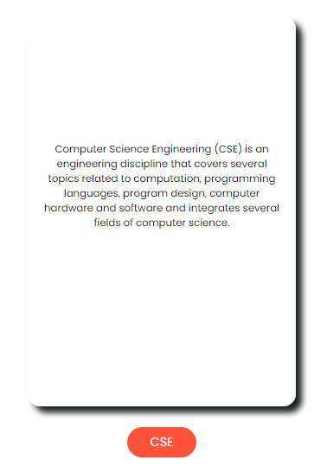

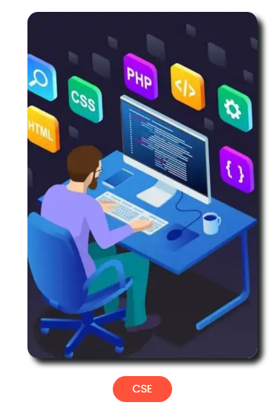

1. **Repository:** <https://github.com/open-sauced/intro>  
   **Issue: Missing Padding Between Sun Icon and Heading**

The interface displays a crucial visual element consisting of a Sun icon and a corresponding heading. However, there is no padding between the Sun icon and the heading, resulting in an undesirable and unappealing layout.

The absence of padding between the Sun icon and the heading negatively affects the user interface's aesthetics and may lead to a suboptimal user experience. Users might find the interface less visually appealing and may have difficulty focusing on the crucial information presented by the heading.



**Soln:**

#docsify-darklight-theme {

left: 308px;

top: 36px;

}

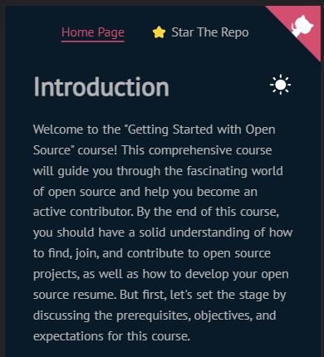

1. **Repository:** <https://github.com/NextExpenseApp/NextExpenseWebsite>

**Issue: Improper flexing of navbar contents**

The contents of the navbar are not flexing correctly, leading to layout issues and misalignment of elements. The navbar, which typically contains various navigation elements and links, is implemented using flexbox or a similar flex-based layout. However, it is observed that the flexing behavior is not functioning as expected.

As a result, the navbar contents may not adjust appropriately to the available space, leading to overlapping, wrapping issues, negative space issues or misalignment of elements.

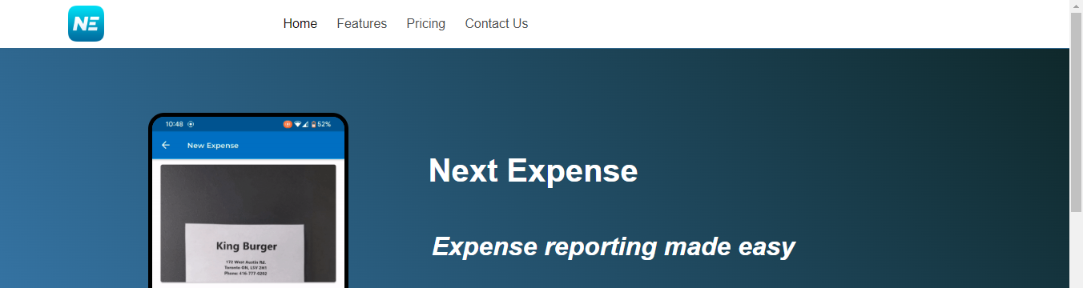

**Solution:**

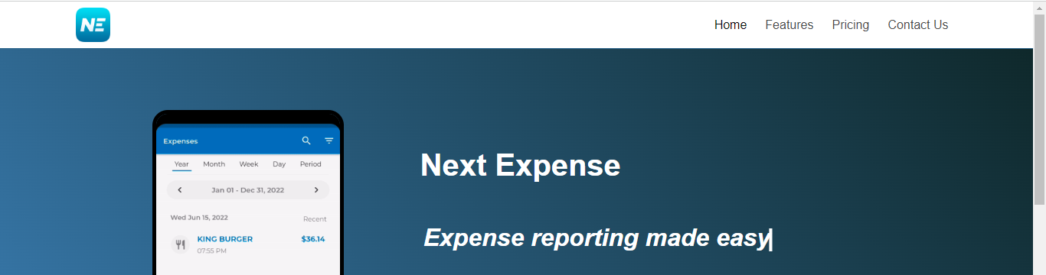

1. **Repository:** [https://github.com/DrewNaylor/tweets-archive-template-website/](https://github.com/DrewNaylor/tweets-archive-template-website/issues/2)

**Issue: Add lazy loading for images**

All the images load at once , this negatively impacts the performance especially when slower network connections or devices with limited resources. To enhance the loading time and user experience, we should implement lazy loading for images.

Images should be loaded only when they become visible in the user's viewport, reducing the initial loading time and network requests.

**Solution**:

<p><img src="avatar.jpg" width="48" height="48" alt="profile picture" class="avatar" loading="lazy" />

1. **Repository**: <https://github.com/bedimcode/responsive-travel-website>

**Issue: Slow Image Transition time Compared to Web Scrolling Period**

In order to make the website creative, Images included in the website had transitions in it. But the transition time was a bit more that's why the image takes more time to load when scrolling through the website. Because of this, The website appears to be blank when navigating through it.

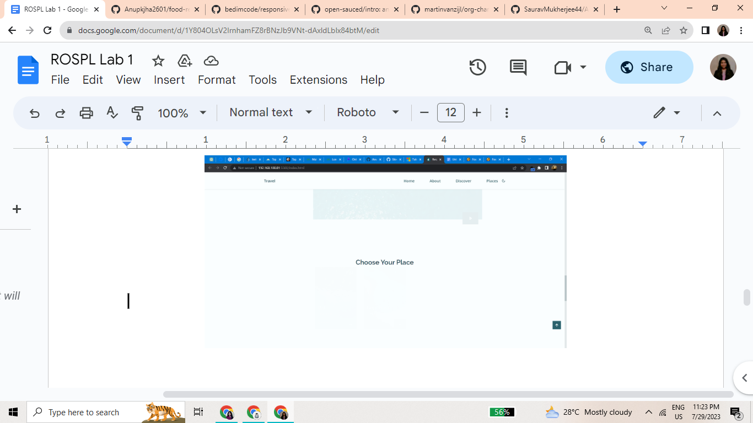

**Solution**: We can decrease the transition time from 0.3s to 0.1s and 0.4s to 0.2s respectively. This way the transitional Images will be visible while Navigation.

**Code**:-

--img-transition: 0.1s;

--img-hidden: hidden;

--img-scale: scale(1.1);

}

@media screen and (max-width: 767px) {

.nav__menu {

position: fixed;

background-color: var(--body-color);

top: 0;

right: -100%;

width: 70%;

height: 100%;

box-shadow: -1px 0 4px rgba(14, 55, 63, 0.15);

padding: 3rem;

transition: .2s;

}

**Output:**

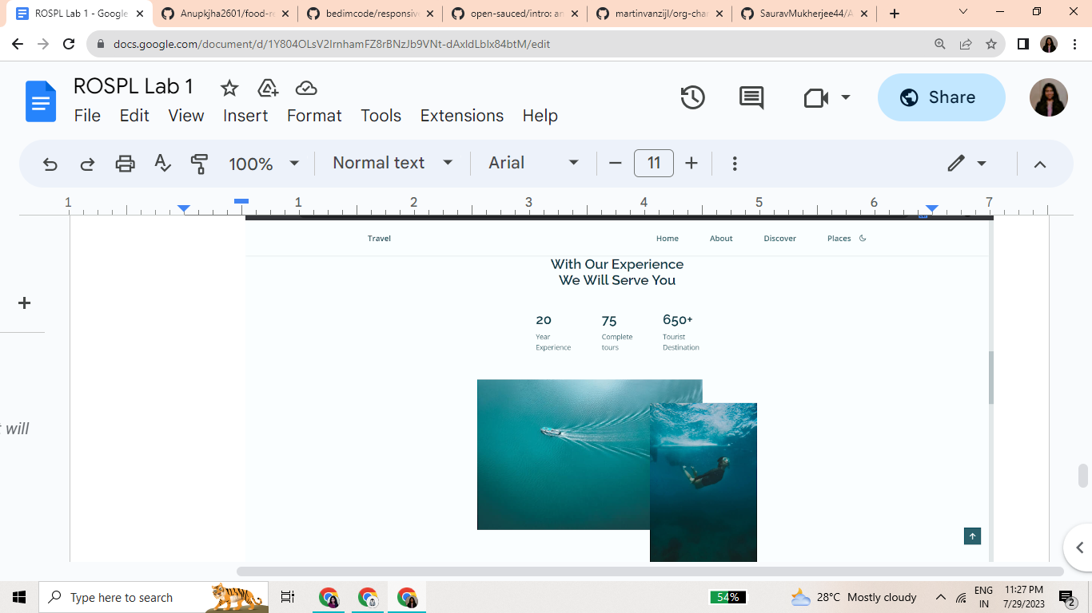

1. **Repository**: <https://github.com/Anupkjha2601/food-recipes-website>

**Issue: Deformation of Navbar in Gallery Page**

The Navbar for Gallery page in the website was deformed. This issue was noticed by us and also already raised on their repository.

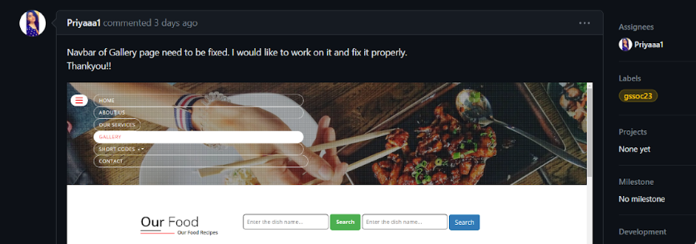

**Solution**: Removing the Unnecessary tags links which caused deformatting of the navbar of the Gallery page .

<!-- <link rel="stylesheet" href="https://cdn.jsdelivr.net/npm/bootstrap@4.3.1/dist/css/bootstrap.min.css" integrity="sha384-ggOyR0iXCbMQv3Xipma34MD+dH/1fQ784/j6cY/iJTQUOhcWr7x9JvoRxT2MZw1T" crossorigin="anonymous"> →

**Output**:

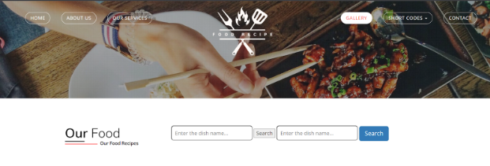

1. **Repository**: <https://github.com/llyram/cloud-farming.git>

**Issue: Navigation between pages**

For navigating through pages, the buttons are redirecting to the same page for the seller as well as the customer.

**Solution**:

<div>

<button><a style="text-decoration: none; color: white;" href="login-seller.html">Login as seller</a></button>

<button><a style="text-decoration: none; color: white;" href="login-customer.html">Login as customer</a></button></div>

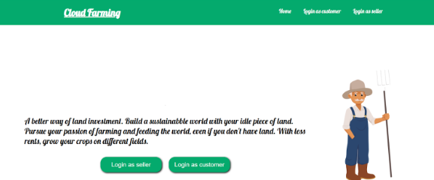

1. **Repository:** <https://github.com/vinita2000/E-Commerce-website-using-html-css-Js.git>

**Issue:** Compressed Images

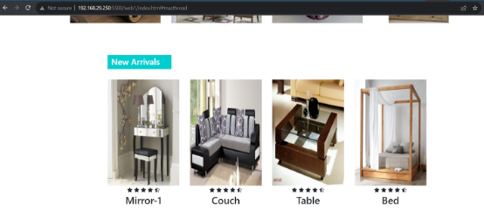

**Solution:**

.product-top img

{

width: 100%;

height: 300px;

object-fit: cover;

}

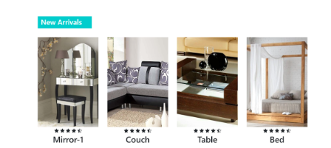

1. **Repository:** <https://github.com/omrajsharma/acciojob-zomato-clone>

**Issue: Search bar not proper sizing.**



**Solution:**

.search {

display: flex;

width: 55vw;

/* justify-content: center; */

align-items: center;

border-radius: 10px;

background: white;

padding: 5px 4px;

